BItFROST – BUDGET AND PLAN

The BItFROST infrastructure will be developed over two years – 2021 – 2022.
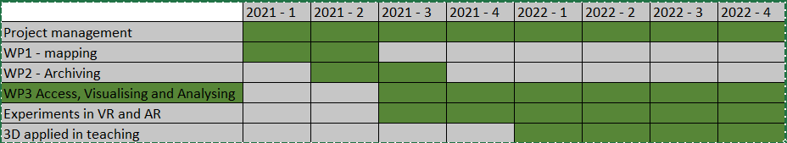

Own financing is 304 650, the total budget is 2 400 367. MCH will cover the cost of the established infrastructure. The detailed budget is as follows:
Budget in NOK
Project Management | Espen Uleberg, 1 month | 78 397 | Own financing
Project leader | Nicolò Dell'Unto, 2 months | 151 252 | Own financing
Development and support for WP 1-3 | The research institution Visual Computing Lab, ISTI, CNR, Italia, , 3 months | 183 938
WP1: Mapping. RG1 and RG1/4. Defining scientific needs for interpretation, evaluation of how 3D models can be used to support advanced research in CH. Identification of critical elements for generating and visualising. | 3 months work at MCH | 206 096
WP2: Archiving. RG 1 and RG2. Construction of the archive after defining requirements for 3D archiving, understanding the dynamics that foster 3D data reuse. | 5 months work at MCH | 343 493
WP3: Access, Visualising and Analysing. RG 3 and RG4. Creating tools for multimodal/cross-disciplinary interaction and definition of a task force for 3D data curation | 6 months work at MCH | 412 191
Experiments in VR and AR:  Developing/establishing interface conventions for access to and presentation of 3D models and enironments for VR/AR use on and off locations (museums and CH sites) | Work coordinated by Gunnar Liestøl, IMK | 515 000 | inc. own financing 75000
Taking part in deciding functionality, develop pedagogic content in certain topics where 3D models are used in teachingccreating new study programs. Exploring the use of VR/AR in teaching. | Work coordinated by Søren Handberg, IAKH | 310 000
Equipment and Data storage in the project period |  | 125 000
 |  | 2 325 367

